Decorate with West Fork Style
Here are two great options for decorating your tree and showing your West Fork pride. These ornaments would make great gifts for the West Fork fans on your Christmas list!

Option A: | 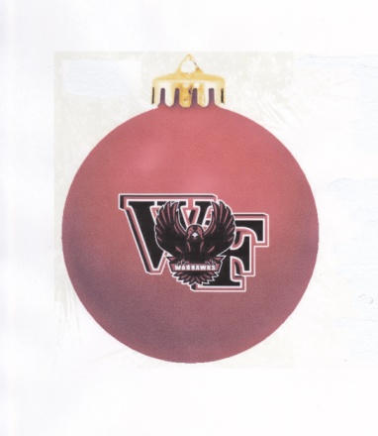 |  | Option A: These ornaments are printed with the logo on one side and West Fork Warhawks on the other. The bulbs are 3.25" around and shatterproof.  $8 each

Option B: | 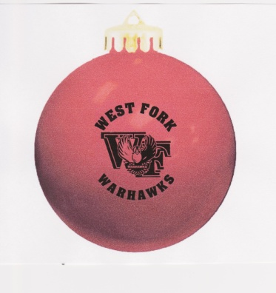 | Option B: These ornaments are printed on one side with the West Fork logo and West Fork Warhawks. The bulbs are about 3.25" around, shatterproof, and come individually boxed.  $6 each

- Orders placed by Nov. 21 will delivered before Thanksgiving Break.
- Final date to order to receive before Christmas Break is Dec. 12.
- Return order forms to school offices in Rockwell or Sheffield. Payment is due with your order.
- Checks payable to: WF Music Boosters/FB Backers

# of bulbs: | Option | Price each | Total
 | A- two sided | x $8 each
 | B-single sided | x $6 each
Grand Total |  |  | $

Name (Student's name if delivering to student):
Phone #: | Student's Grade:
Order by Nov. 21 to receive by Nov. 26. Final day to order to receive before Christmas Break is Dec. 12. Thank you for supporting the Music Boosters and the Football Backers in this joint fundraiser!

